**CHKN-93 – Research how to limit file types**

Maybe a script on their repo or admin checks if js

**Different Methods to Limit File Type**

1. Use a script to check the GitHub

* Not 100% sure how we would do this but here are some custom libraries in Python and C# that can be used to check file types
* <https://github.com/turboyang-cn/TurboYang.Utility.FileSignature> (C#)
* <https://github.com/ghost1face/FileTypeInterrogator?tab=readme-ov-file> (C#)
* <https://github.com/ua-nick/fleep-py> (Python)

1. Use Regular Expression

* Could simply use a regular expression to check if a file ends in .js.

1. Use HTML check

* HTML <input> tags have a file type and then you can limit them to only accept certain types of files. I am not quite sure how this would work with what we currently have but I figured it was worth documenting.

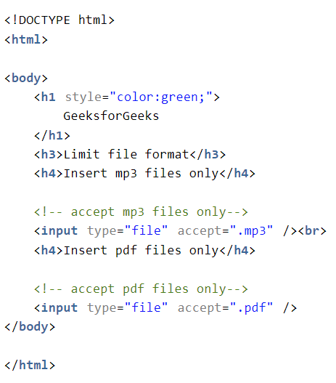

1. Admin manually checks

* An admin manually goes into the game addition requests and ensure the file is in javascript.